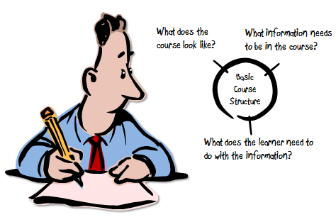
FINALLY
training course
proposed modules and content
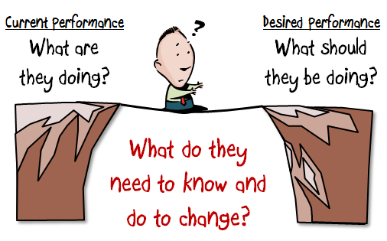

Partner institution: FEUN – Faculty of Economics University of Niš Serbia

Identified Target Group’s Financial Literacy Needs in your country [1]
Identified need: rational spending
Identified need: additional incomes
Identified need: personal finances planning, strategic planning
Financial illiteracy: lack of knowledge and understanding of financial matters
Financial incapability: behavioral boundaries (e.g. incomplete acceptance of materialism and selfishness), decision-making shortcomings (lack of planning, ignorance of future)
Social ambience: family interdependence and solidarity within wider social groups, alienation from state, values specific for Roma (e.g. higher social importance of non-material values).

Proposed titles for one or more Training Modules that you consider essential [2]
Module 1 proposed tile: Basic financial terms and expressions
Module 2 proposed tile: Personal budgeting
Module 3 proposed tile: Understanding main financial concepts and products

Proposed Topics for the modules that you would like to propose [3]
Module 1: Basic financial terms and expressions
Proposed topics:
1.1. Revenues: sources, time pattern (seasonality, uncertainty), legal context (consequences)
1.2 Expenditures: types, time pattern, order of importance (necessity, excessiveness)
1.3 State and individual: taxes and benefits (e.g. social security)
Module 2: Personal budgeting
Proposed topics:
2.1 Managing money by keeping track: having an overview of expenses
2.2 Planning revenue and expenses ahead: being future oriented
2.3 Making ends meet: align his/hers expenses with the income
2.4 Reducing expenses: shop effectively, orientate on savings, Rationalize purchases (making and using shopping lists and similar tools, smart use of discounts, cupons etc.)
2.5 Increase income: basics of entrepreneurship
Module 3: Understanding main financial concepts and products
Proposed topics:
3.1 Cash and alternatives: managing pocket money
3.2 Saving, investment and insurance products: get award for patience, understand risk-return profile
3.3 Be on equal footings with financial services providers: calculating interest, fees, taxes on their own

Skills and Knowledge expected to be gained through the proposed modules [4]
Module 1 - Skills and Knowledge expected to be gained:
Understanding the concept of financial security in ever-changing world
–money flows differs from financial flows: having money in the pocket is not the same as being financial secure
–financial assessment by looking ahead: be able to assess individual or family financial position for a lifetime of financial well-being

Module 2 - Skills and Knowledge expected to be gained:
Better management of personal finance
–making ends meet (short-term focus): having little problems dealing with everyday financial obligations
–making life secure (long range focus): foreseeing future needs and acting ahead
Module 3- Skills and Knowledge expected to be gained:
Educate Roma how to responsibly explore their own financial possibilities
–choosing financial products: deciding reasonably in financial matters
–staying informed: seeking information on financial products and economy

Proposed Training Approach and Techniques for the specific module [5] & Proposed Training tools [6]
Module 1: workshops – brainstorming on categories of incomes and expenses, making lists of all in each category at the level of household and trying to balance; discussion on specifics of each of the item in both groups (incomes and expenses); group work – how to save on some of the expenses, how to prioritize, etc.
Module 2: making list of personal incomes and expenses according to memory for a last month and a year – discussion; making list of foreseen personal budget in the next month/year; - discussion; group work: making recommendations for better personal finance management; simulation of consumer behavior before and during purchase – or analyzing various stories on affective buying, not planned purchase etc.; individual work: making shopping lists – each of the participants, and then optionally giving it to other participant to revise, after which the group discussion follows….

Module 3: few recommendations for training techniques
Group exercise of getting information (bank office simulation): what information about financial products do you need, and where to ask for?
Games of investment: start with equal amount of money and choosing between different options; The winner is one who get retired with highest amount of money
Exercise on how to avoid debt overload: survival by aligning personal income, expenditures and debt burden

Other Comments [7]
Module 1: ………………………………………………………………….
Module 2: …………………………………………………………………
Module 3: …………………………………………………………………

Notes – How to handle the Template and make a valuable contribution.
The space provided for the various items in this Template, is indicative. Expand it and enter as much text as you wish! We expect to receive as much information as possible and process it, in order to come up, with your cooperation, with a meaningful and effective training course design serving the financial literacy needs of the target group in our respective countries.
We thank you in advance for your effort!

1. The work you carried out in the context of the Needs Assessment Work Survey in your country, allowed you to identify a number of acute financial literacy training needs of the target group. List these “needs” and add, for each of them, a short text explaining their basic character. List, in order of perceived priority, as many such “needs” as you consider useful to be recorded.
2. We expect that each of thsee “needs” could be covered by appropriately designed training modules (probably lasting 4-5 hours each). Think creatively and propose an attractive title for such training modules. The title proposed should be sufficient to allow interested trainees-to broadly understand what they are going to be trained in.
3. Let us now get into more details! You already indicated a “title”, suggesting a general framework for each module. Be now more specific and list, for each of your proposed modules, the specific topics that you think the module should cover. Use as much text as you think adequate to indicate what these topics should be.
4. You have so far, in previous sections, indicated the “need» and already suggested how, through certain training modules each discussing a number of topics, how the target group’s “need” will be adequately covered. Indicate now the type of skills and knowledge expected to be acquired by the trainees through each training module.
5 and 6. Whether you posses previous experience in this or not, please share with us “ideas” that you might have on how the training of the specific target group could be more efficiently and effectively be implemented. What training methods should be used? How should trainers operate in order to make training more attractive thus encouraging trainees’ engagement and active participation strengthen their absorption of messages and advice conveyed and, as a result, make the Course a “success”!
We also need your ideas on what type of training Tools could or should, in your opinion, be used. For example: “stories”, role playing, exercises, templates for homework, games, quizzes etc. The Tools development is a task for WP4, but it is closely related to what is being examined here. More work on Tools will be needed and, once more, we will call on your cooperation!
7. Do you have anything else to add? Perhaps something that you wanted to report but you could not decide on which section to put it.

For the project’s Work Plan to “stay on track” and to smoothly and timely move from one stage to the next, we would be grateful if you could complete this work NOT LATER THAN FRIDAY 25, 2013. In the meantime, if there are issues that you would like to discuss or if further clarifications are needed, do not hesitate to contact us!

Thanks, once more, for your cooperation!


The project FINALLY is co-funded by the Lifelong Learning Programme of the European Union. This text reflects the views only of the author, and the Commission cannot be held responsible for any use which may be made of the information contained therein.

